I am the original document.

**This sentence is bold and will be removed in a later draft.**

This sentence should have a comma instead of a period, However this mistake will be corrected in a future draft.

This sntence has a misspelling which will be corrected in a future draft.

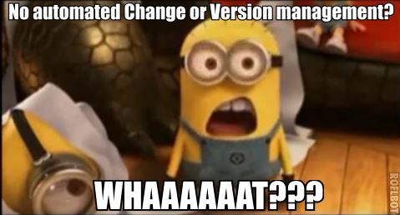

# Should this really be in H1 format? Maybe someone will change me in another draft.

Should this misplace subtitle be deleted? Maybe it will be in another draft.